Jenkins Exercises

# Exercise 1: Freestyle Job - Windows File Transfer Automation

1. **Objective:** Automate file transfer between two directories on a Windows machine.
2. **Steps:** 
   * Create a Freestyle Job in Jenkins. o **Configure the job to execute a Windows batch command:**

xcopy C:\source-directory C:\target-directory /E /I /H /Y

* + Add a post-build action to check the success of the transfer using a custom message.

1. **Task:** Test the job by placing some files in the source directory and verifying they are transferred to the target directory.

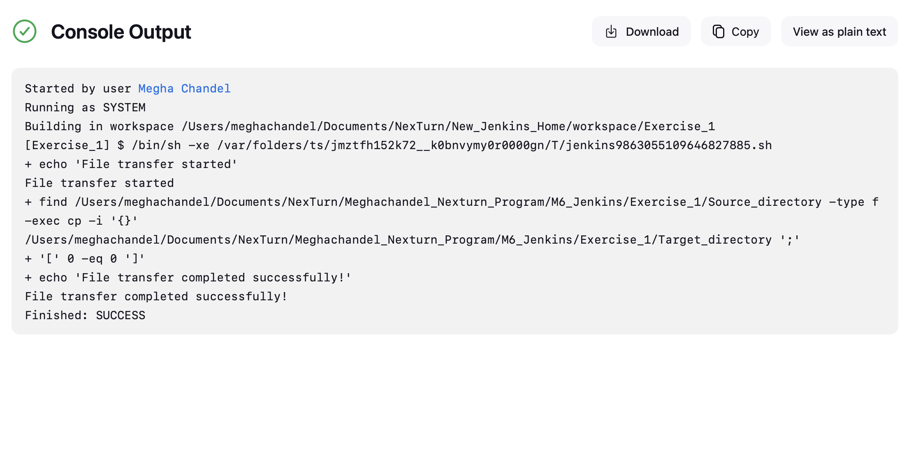

# Exercise 2: Freestyle Job - Build and Deploy a JavaScript Project

1. **Objective:** Build and deploy a JavaScript-based web project.
2. **Steps:** 
   * Create a Freestyle Job.
   * **Configure the job to:** 
     + Clone a JavaScript repository (e.g., a React project) from GitHub.
     + Run npm install to install dependencies.
     + Build the project using npm run build.
     + Copy the build folder to a deployment directory using a Windows batch command or PowerShell.
   * Archive the build artifacts for future reference.
3. **Task:** Verify the deployment by accessing the web application from the deployment directory.

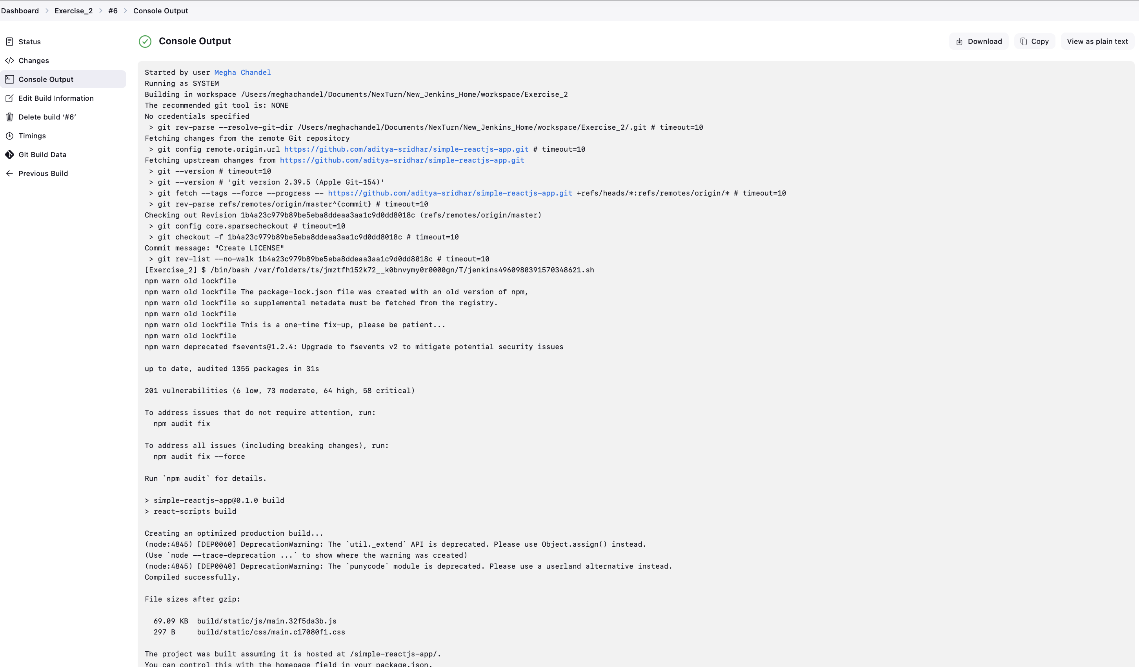

# Exercise 3: Freestyle Job - Flask Application Deployment

1. **Objective:** Automate the deployment of a Flask application.
2. **Steps:** 
   * Create a Freestyle Job.
   * **Configure the job to:** 
     + Pull the Flask application repository from GitHub.
     + **Set up a virtual environment using Python:**

python -m venv venv .\venv\Scripts\activate pip install -r requirements.txt

* + - Start the Flask development server.
  + Add a post-build action to verify the server is running (e.g., using curl or a similar tool to hit a test endpoint).

1. **Task:** Test the application deployment by accessing it via localhost.

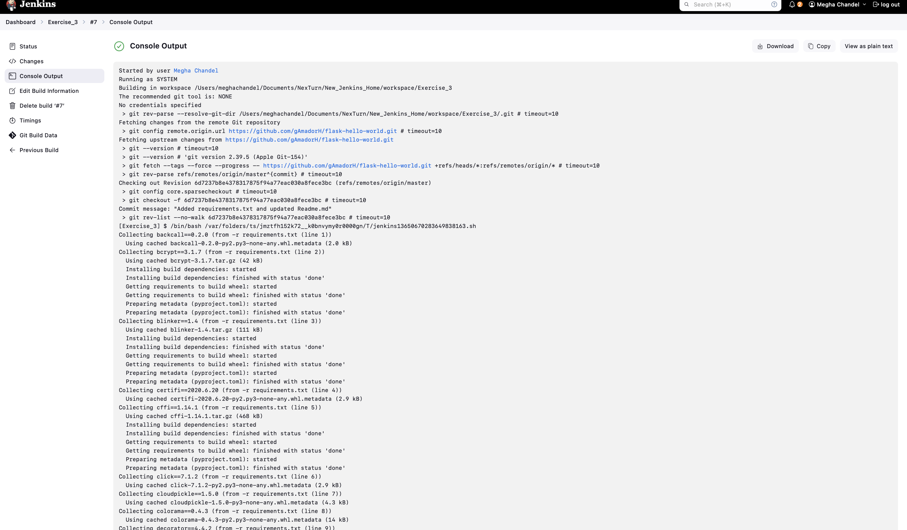

# Exercise 4: Pipeline Job - End-to-End CI/CD for a React Application

1. **Objective:** Implement a CI/CD pipeline for a React web application.
2. **Steps:** 
   * Create a Pipeline Job.
   * **Write a Jenkinsfile to:** 
     + Clone the React project from GitHub.
     + Install dependencies (npm install).
     + Run tests (npm test).
     + Build the project (npm run build).
     + Deploy the application by copying the build folder to a deployment directory.
   * **Add stages for:** 
     + Linting using ESLint.
     + Post-deployment testing using curl to verify the app is running.
3. **Task:** Run the pipeline and validate each stage's output.

# Exercise 5: Pipeline Job - Deploy a Flask Application with Gunicorn

1. **Objective:** Automate the deployment of a Flask application with Gunicorn on Windows.
2. **Steps:** 
   * Create a Pipeline Job.
   * **Write a Jenkinsfile to:** 
     + Clone a Flask application from GitHub.
     + Set up a Python virtual environment.
     + Install required packages using pip install -r requirements.txt.
     + Configure and start the Gunicorn server:

gunicorn -b 127.0.0.1:8000 app:app

* + - Verify the deployment using a curl command in the pipeline.
  + **Add stages for:** 
    - Unit tests using pytest.
    - Post-deployment endpoint checks.

1. **Task:** Trigger the pipeline and ensure the Flask app is accessible on localhost.